**TRAIN_HAM_PROCESSED:**

1. Word Cloud.

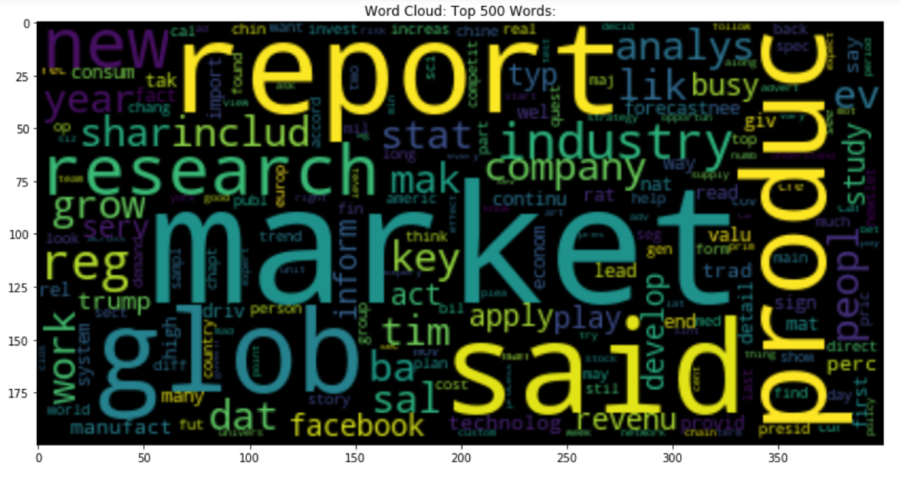

1. Top 50 single words.

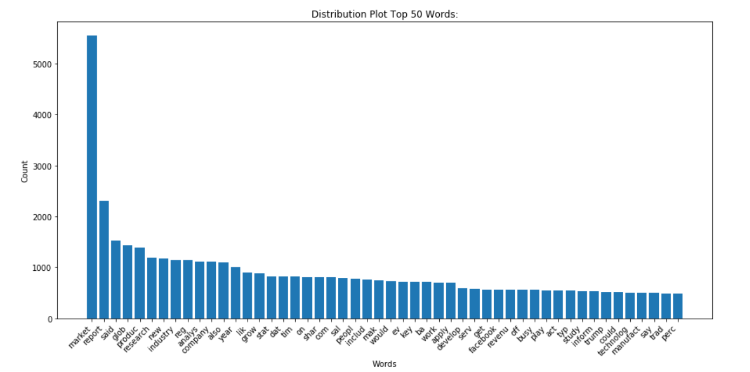

1. Top 50 double words.

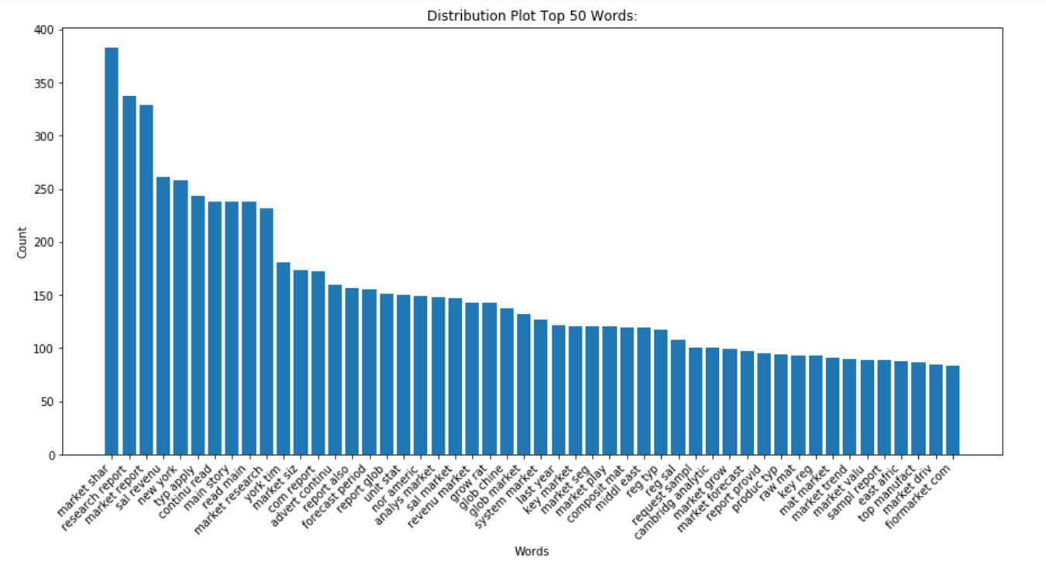

1. Top 50 triple words.

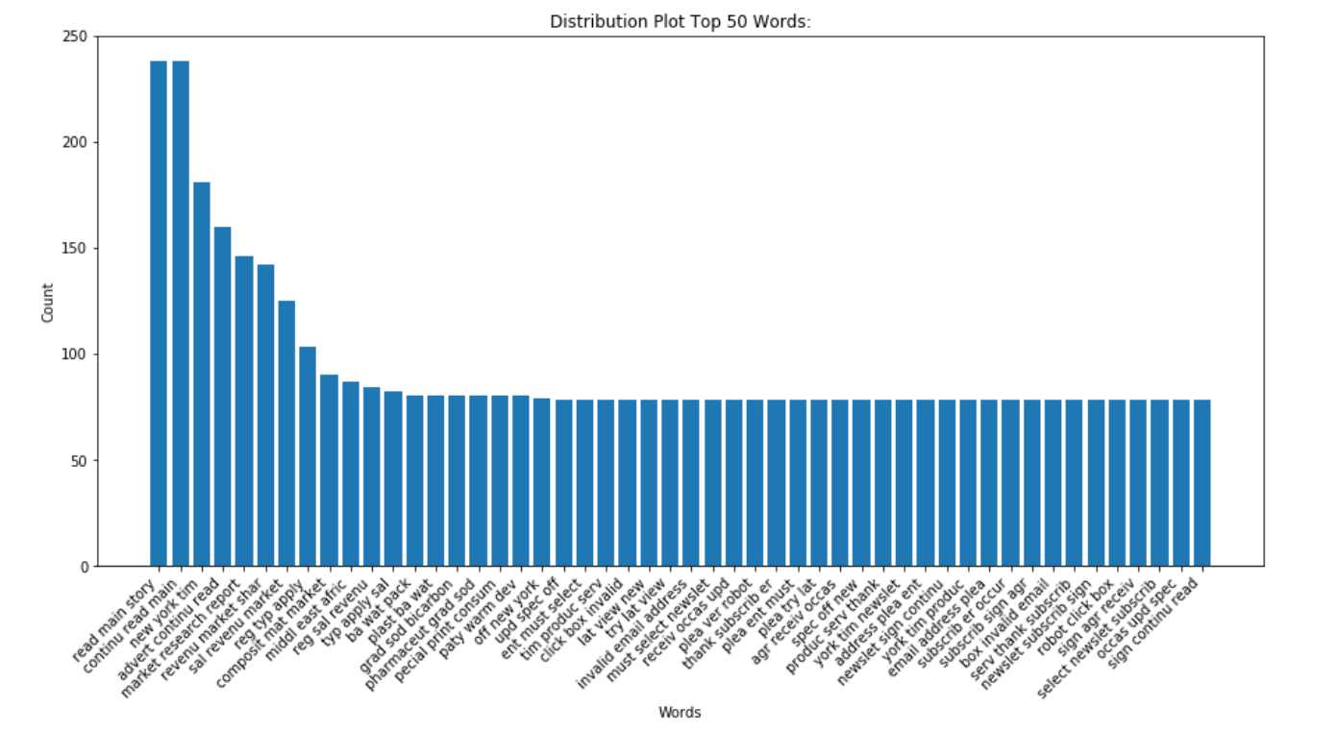

**TRAIN_HAM_PROCESSED_POS:**

1. Bag of words POS.

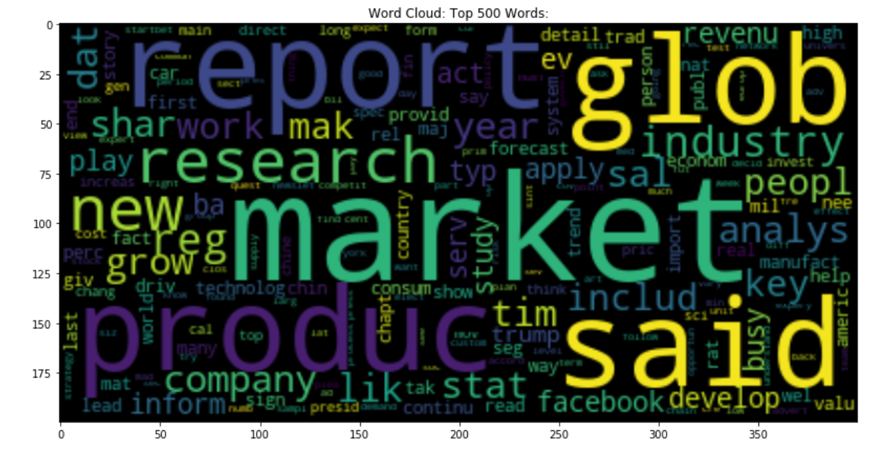

1. Top 50 single words POS.

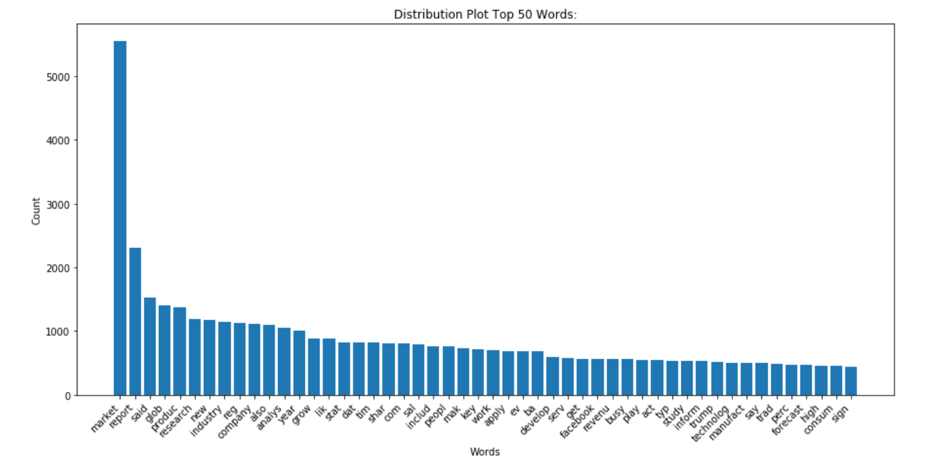

1. Top 50 double words POS.

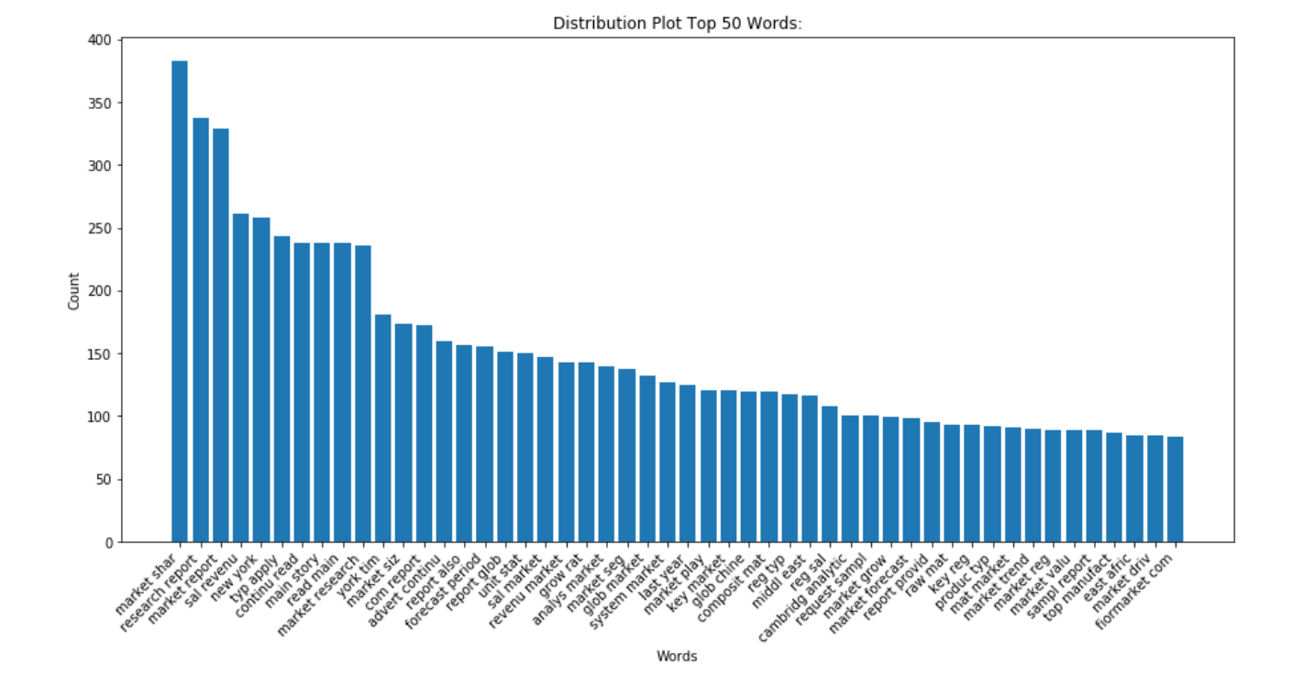

1. Top 50 triple words POS.

